In this week’s recap: Coronavirus continues to drive the markets, even as bankers and health professionals take decisive steps to stem the tide.
Weekly Economic Update

March 23, 2020

THE WEEK ON WALL STREET
The stock market suffered through another volatile week as it wrestled with the health and economic fallout of the domestic spread of the coronavirus. Swift and decisive actions by the Federal Reserve and policy responses from the federal government did not keep stocks from recording losses for the week.
The Dow Jones Industrial Average slumped 17.3%, while the Standard & Poor 500 lost 14.98%. The Nasdaq Composite index declined 12.64% for the week. The MSCI EAFE index, which tracks developed overseas stock markets, fell 6.64%.¹⁻³
Stocks Slide Further
The stock market continued its retreat amid fears of a darkening economic impact from the coronavirus pandemic. Despite a Sunday night announcement by the Federal Reserve that it was cutting its benchmark interest rate by 100 basis points to nearly zero and taking steps to increase market liquidity, stocks opened the week sharply lower, setting the stage for another difficult week for investors.⁴
Progress was reported on coronavirus testing capacity and on the efforts to combat the infection. At the same time, Washington, D.C., advanced legislation to provide financial assistance to unemployed workers and affected businesses. Neither did much to help investor anxieties, however. Stocks slid in the closing hours of the trading week, leaving stock indices near their lows of the week.⁵

Central Bankers Go Big
The response of global central bankers to mitigate the economic impact of the coronavirus has been broad ranging. In addition to its 100 basis point cut in the federal funds rate, the Federal Reserve also took actions to provide additional credit access to banks, committed to buy at least $700 billion in Treasury and mortgage bonds, and set up a new lending facility to backstop money market funds.⁶
The European Central Bank also announced an $800 billion-plus bond buying program to support member economies. The Bank of England cut its benchmark lending rate to 0.1% and pledged to buy over $200 billion in government and investment grade corporate bonds, while the Bank of Japan said that it would double its purchases of stocks and increase loans to businesses.⁷⁻⁹

Final Thought
Investors are struggling with answers to two unknowns: the trajectory of the coronavirus spread and its economic cost. With coronavirus testing beginning to ramp up, these numbers may begin drawing a firmer picture of the growth of coronavirus infections in the U.S. Economic indicators, such as jobless claims for unemployment insurance and the Index of Leading Economic Indicators, may provide clues regarding the economy.

T I P O F T H E W E E K
Federal student loans may offer 6-month grace periods before any repayment is necessary, but having an income-based repayment plan in place soon after graduation is wise. Repayments can be limited to affordable amounts through these plans.

THE WEEK AHEAD: KEY ECONOMIC DATA
Tuesday: New Home Sales.
Wednesday: Durable Goods Orders.
Thursday: 4th-quarter GDP (Gross Domestic Product) Report. Jobless Claims for Unemployment.
Friday: Consumer Sentiment.
Source: Econoday, March 20, 2020
The Econoday economic calendar lists upcoming U.S. economic data releases (including key economic indicators), Federal Reserve policy meetings, and speaking engagements of Federal Reserve officials. The content is developed from sources believed to be providing accurate information. The forecasts or forward-looking statements are based on assumptions and may not materialize. The forecasts also are subject to revision.
THE WEEK AHEAD: COMPANIES REPORTING EARNINGS
Tuesday: Nike (NKE), Carnival Corp. (CCL).
Wednesday: Micron Technologies (MU).
Thursday: Lululemon (LULU), KB Home (KBH).
Source: Zacks, March 20, 2020
Companies mentioned are for informational purposes only. It should not be considered a solicitation for the purchase or sale of the securities. Any investment should be consistent with your objectives, time frame and risk tolerance. The return and principal value of investments will fluctuate as market conditions change. When sold, investments may be worth more or less than their original cost. Companies may reschedule when they report earnings without notice.

Q U O T E O F T H E W E E K

“I'd take the awe of understanding over the awe of ignorance any day.”
DOUGLAS ADAMS

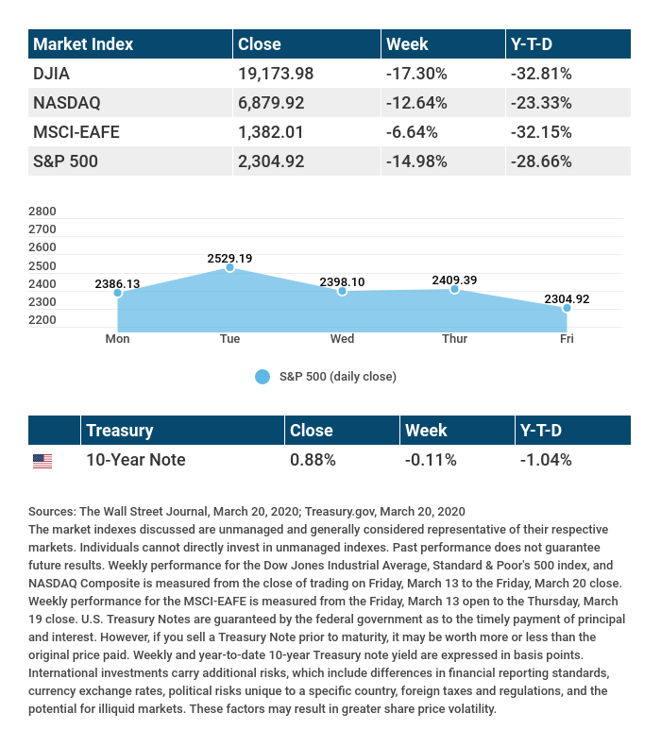

T H E W E E K L Y R I D D L E

A man pocketed it and took it home, intending to eat it. He put it on a shelf, but three days later, it walked away. What was it?

LAST WEEK’S RIDDLE: What can fill a room, yet takes up no physical space?
ANSWER: Light.

Know someone who could use information like this?
Please feel free to send us their contact information via phone or email. (Don’t worry – we’ll request their permission before adding them to our mailing list.)
Chris Hass, Jeff Caufield and Chad Perkins offer securities through Parkland Securities, LLC. Member FINRA/SIPC. Investment advisory representatives offer investment advisory services through Sigma Planning Corporation, a registered investment advisor. Corvus Capital, LLC is an independently owned company located at 2950 Breckenridge Lane, Suite 6, Louisville, KY 40220. Phone (502) 451-6363; Fax (502) 451-6364

This material was prepared by MarketingPro, Inc., and does not necessarily represent the views of the presenting party, nor their affiliates. The information herein has been derived from sources believed to be accurate. Please note - investing involves risk, and past performance is no guarantee of future results. Investments will fluctuate and when redeemed may be worth more or less than when originally invested. This information should not be construed as investment, tax or legal advice and may not be relied on for the purpose of avoiding any Federal tax penalty. This is neither a solicitation nor recommendation to purchase or sell any investment or insurance product or service, and should not be relied upon as such. All market indices discussed are unmanaged and are not illustrative of any particular investment. Indices do not incur management fees, costs and expenses, and cannot be invested into directly. All economic and performance data is historical and not indicative of future results. The Dow Jones Industrial Average is a price-weighted index of 30 actively traded blue-chip stocks. The NASDAQ Composite Index is a market-weighted index of all over-the-counter common stocks traded on the National Association of Securities Dealers Automated Quotation System. The Standard & Poor's 500 (S&P 500) is a market-cap weighted index composed of the common stocks of 500 leading companies in leading industries of the U.S. economy. NYSE Group, Inc. (NYSE:NYX) operates two securities exchanges: the New York Stock Exchange (the “NYSE”) and NYSE Arca (formerly known as the Archipelago Exchange, or ArcaEx®, and the Pacific Exchange). NYSE Group is a leading provider of securities listing, trading and market data products and services. The New York Mercantile Exchange, Inc. (NYMEX) is the world's largest physical commodity futures exchange and the preeminent trading forum for energy and precious metals, with trading conducted through two divisions – the NYMEX Division, home to the energy, platinum, and palladium markets, and the COMEX Division, on which all other metals trade. Additional risks are associated with international investing, such as currency fluctuations, political and economic instability and differences in accounting standards. This material represents an assessment of the market environment at a specific point in time and is not intended to be a forecast of future events, or a guarantee of future results. MarketingPro, Inc. is not affiliated with any person or firm that may be providing this information to you. The publisher is not engaged in rendering legal, accounting or other professional services. If assistance is needed, the reader is advised to engage the services of a competent professional. The market indexes discussed are unmanaged and generally considered representative of their respective markets. Individuals cannot directly invest in unmanaged indexes. Past performance does not guarantee future results. The return and principal value of investments will fluctuate as market conditions change. When sold, investments may be worth more or less than their original cost.
CITATIONS:
1 – The Wall Street Journal, March 20, 2020
2 – The Wall Street Journal, March 20, 2020
3 – The Wall Street Journal, March 20, 2020
4 – CNBC.com, March 15, 2020
5 – CNBC.com, March 20, 2020
6 – The Wall Street Journal, March 19, 2020
7 – CNBC.com, March 19, 2020
8 – Pension & Investments, March 19, 2020
9 – Financial Times, March 16, 2020
CHART CITATIONS:
The Wall Street Journal, March 20, 2020
The Wall Street Journal, March 20, 2020
Treasury.gov, March 20, 2020

